**Amity University Dubai**

Dr. Mehrdad Mohasses

Dr. Riadh Belkebir

Ms. Aysha Musthak

Ms. Rasheeda Shireen

**Project: Data Scraping**

# Goal

To retrieve data related to competencies for advertised jobs in the UAE market.

## Sectors

* Pharmaceutical
* Autonomous Car (Automobile)
* Retail
* E-commerce
* Cybersecurity
* Aluminium
* Transport
* Banking
* Accommodation
* Nuclear

## Sites for data scraping

* LinkedIn
* Indeed.ae
* Bayt.com
* Gulftalent.com
* Monstergulf.com
* Naukrigulf.com

# Categories of Competencies

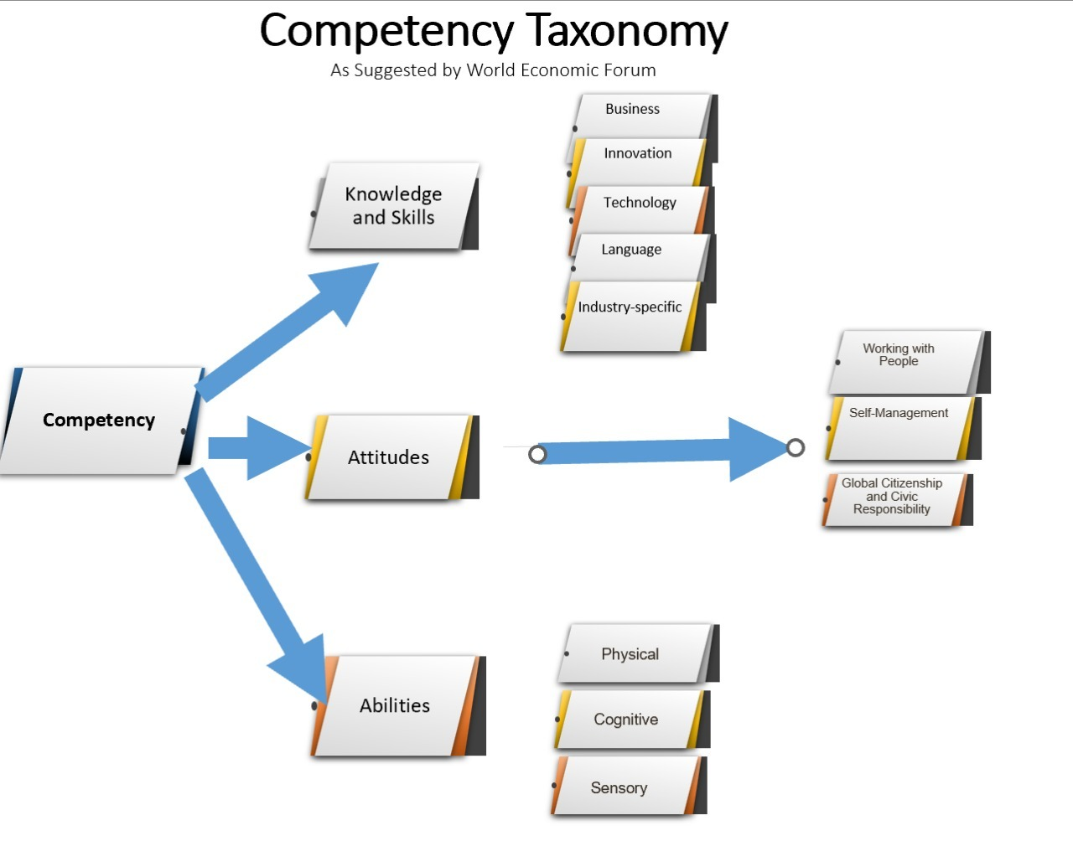

# ReadMe:

# 1.LINKEDIN

Scraping job postings data from LinkedIn

Using Selenium and BeautifulSoup

**Steps:**

* Install chrome web driver
* Access the LinkedIn webpage
* Use your login credentials
* Access the LinkedIn page for the job and country using the respective link
* Find the job, company and location from the job postings webpage
* Access all the job posting pages to get the job description
* Clean the description to get only necessary job requirements
* Create a data frame using all the accessed jobs, companies and locations
* Export the result to a CSV file

**References:**

<https://medium.com/analytics-vidhya/selenium-and-beautifulsoup-webscraping-linkedin-job-description-f4ed2be1455c>

<https://github.com/saulotp/linkedin-job-description-scrap>

**2. INDEED**

Scraping job postings data from LinkedIn

Using requests and BeautifulSoup,

**Instructions:**

* Run the code through jupyter notebook or google colab
* For scraping the text from the websites, find the ID of the corresponding html tags though the inspection tab(Ctrl+I).
* Check out the video below for more clarity

References:

[(53) How to scrape JOB posts from INDEED with PYTHON - YouTube](https://www.youtube.com/watch?v=eN_3d4JrL_w&t=372s)